The City of Minneapolis: Progressive or Just Making Progress?

MPP 412 Urban Politics
Annette Steinacker
12/12/21

Table of Contents
Introduction 3
Background: 4
The City of Minneapolis: Population & Demographics 4
Strategy # 1 8
Minneapolis: Redistributive policies & Fiscal Stability 8
Strategy # 2: 10
The Minneapolis voters’ effect: Power of voice, elections, and interest groups 10
Strategy # 3: 16
Minneapolis political structures: measuring progress 16
Conclusion 21
Appendix: 21
References: 23

Introduction

As a collective, the city of Minneapolis though perhaps making strides towards general consideration of a “progressive” city, it can be argued, remains neoliberal or entrenched in Neoliberal city politics. Through its various redistributive policy efforts, though they are feasibly accomplished, arguably haven’t been proven to be as effective.
For the city of Minneapolis, as many other US cities, policies are often influenced in constraints that are two-fold. The first signifier is when decisions for the city are made federally, i.e., the city acts in decision-making that is in accordance with the state and national levels. The 2nd constraint is how economic or fiscal limits can restrict formation of new city policy. Both factors are often large contributors to the neoliberal city. Further, Minneapolis though outwardly presented as a more “progressive” city, runs into both constraints with their city policy building.
For Minneapolis to outweigh these criticisms of neoliberalism, theoretical solutions can be presented in the argument for Minneapolis’ push toward a progressive city. Three strategies to combat Minneapolis’ entrapment in neoliberalism are as follows; the first, is that a city must continue to provide redistributive services and policies that will benefit all citizens, versus the privileged few. If this is successful, it will not only aid “the average taxpayer”, but it will also lessen citizens “ability to exit”, keeping the city economically balanced. The 2nd, strategy will argue the effectiveness of citizens role in advancement of a city’s progressiveness. For this strategy to be successfully feasible, propositions such as voice, public elections/councils, and coalition building, will need to be constructively present and active. Finally, the 3rd strategy to outweigh Minneapolis roots in neoliberalism, will be to what effect the levels of progressive structures within the city are positively measured and addressed. For this 3rd and final strategy to succeed, four structure areas that deem a city progressive, can be analyzed in their achievability throughout the city of Minneapolis.
Each overall strategy, aided with collection of city data, can provide evidence as to whether Minneapolis could be ruled “progressive,” or is only simply moving in that direction. Beginning with a background of Minneapolis, measurements of populations race, Median Income, Age, and so forth, from the year 2010-present day can illustrate where the city stands demographically. Then, the essay will argue whether the three strategies can be successfully implemented while refuting the constraints that keep cities such as Minneapolis, stagnant in neoliberal city policy.

Background:

The City of Minneapolis: Population & Demographics

With a total current population of over 420,000 citizens, Minneapolis ranks # 46 in the United states out of 50 largest US cities by population, while remaining the largest city within the state of Minnesota. As a demographic, Minnesota remains largely white and middle class, but over time has seen its Black, Latinx, Asian, and other immigrant populations rise. Using the source “data.census.gov,” the demographic information for the year 2020 could be found, as the source had the Minneapolis population chronologized from the past 10 years through now. Through cross-referencing collected data with that from “datausa.io,” more of these statistics could be viewed through color-blocked maps, seen in Figure 1.
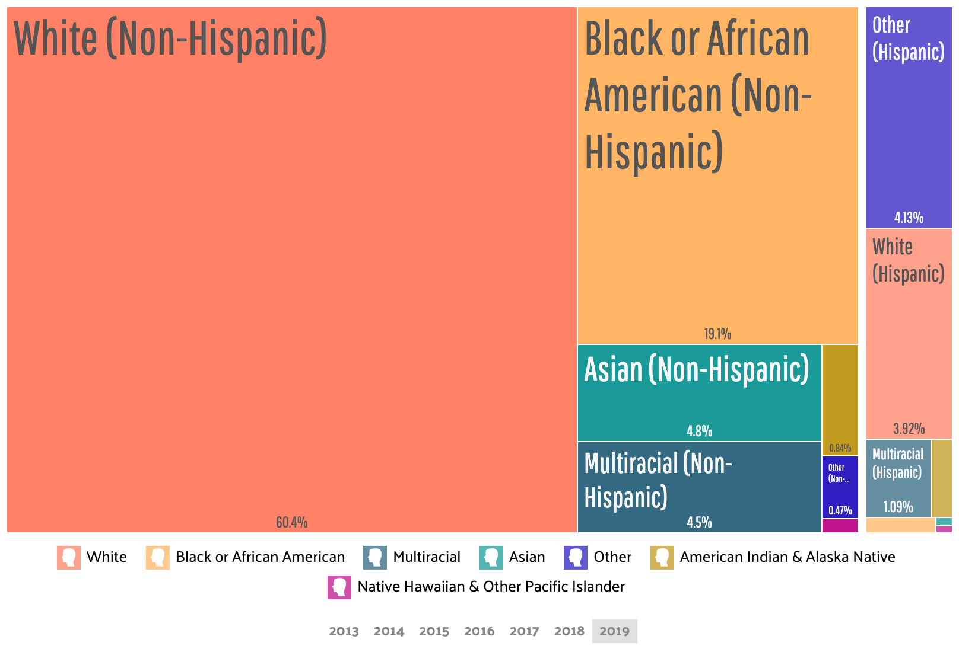
(Figure 1)
(Source: https://datausa.io/profile/geo/minneapolis-mn)
Further, in the city of Minneapolis from the years 2010 through 2019-2020, there wasn’t a large increase or decrease in the population. Touching on citizen exit, in Minneapolis from 2019 to now, there wasn’t a notable population change, leading to the belief that there wasn’t general exit displayed. Instead, the population had a sizeable increase from the year 2010 to the year 2019, gaining a total population amount of 47,376 .
When it comes to the diversity of the city of Minneapolis, numbers begin to vary. The number of white people seemingly decreased from 2010 at 69.3% to 64.3% by 2020, so here it can be argued that there was general exit singularly from Minnesota’s white population from the inner city. Another race that saw decline was Asian Americans, who held a total population percentage of 5.6% in 2010 but decreased to 4.8 in 2019. I assume that these two specific population types chose to exit because other groups, particularly Black/African American and Latinx populations, began to dominate the Minneapolis city neighborhoods, therefore expanding that populations.
As far as noticing changes in city composition in accordance with citizens and median income, author Paul Peterson would argue that outside of Hirschman’s theory of exit, there is also the “above average taxpayer,” who when city policy changes, can be influenced to stay or exit due to economic change occurring in the city. In reference to Minneapolis and the taxpayer’s median household income, there wasn’t necessarily an “above average taxpayer” decline, because the population whose income was over $100,000 was 11.9% in 2010 and when up to 18.9% in 2020 (a 7% increase). The city did however, experience gentrification, while simultaneous having an expansion in its job growth from 2010, making for the above average taxpayer population to experience a steady incline rather than a general exit. High quality service demanders, were somewhat present, seeing as the number of children under five increased from 2010 to 2019, however children in age groups 5-10 and 19-29 saw a decrease. It can be argued that demanders such as the education system, crime, and social impact could each have made families have fewer children or cause exit from the city altogether.
After analyzing data collection in demographics from the past 10 years, it can be argued there was possibility of general exit from the city of Minneapolis from select groups. However, one example to measure another precise possibility of exit, would be a signifier like the cities social change. Minneapolis was one of the largest cities in the world to undergo social protests after the killings of Black and African Americans, mostly due to crimes of police brutality. Starting in 2015 and coming to a massive head in 2020, there was an excessive amount of civil unrest in and around the urbanized areas of Minneapolis. This test could give insight into why there was gain of certain populations and an exit of others. This is even more apparent when you see a large decline in white populations and a steady increase in all other races (apart from Asian Americans) However, “voice as a substitute for exit,” through signifiers such as “social and civil change,” within city of Minneapolis becomes difficult to measure recently, when there are other intervening variables. For example, the ongoing coronavirus pandemic and its impacts on the population heavily impacted the state and Minneapolis citizens, with over 961 thousand cases. This outside factor skewed statistics of not only current demographics but could also cause an imbalance in statistics for disadvantaged groups, since this disease was worse for people of color and low-income citizens. Further, another threatening variable to recent city population measurements is corrupted census data, after the previous administration targeted specific races. According to a study at the end of last year “millions of census records for 2020 could be flawed after former President Trump's push to exclude unauthorized immigrants from a key census count.” (npr.org) Such previous intervening variables can impact service demanders such as social change, causing inaccuracy in population demographics for the years 020-2021, in the city of Minneapolis.

Strategy # 1

Minneapolis: Redistributive policies & Fiscal Stability
For a city to be progressive, it needs to attempt to provide redistributive services and policies that will benefit all communities. However, both constraints that aid neoliberal policy and limit feasibility for progressiveness come into play in several cities, Minneapolis included. The Minneapolis government often can’t help everyone, so at that point the state would need to step in and aid. However, with Federalism comes restriction, especially when it comes to fiscal policy. In Urban Politics, its discussed how while it can be up to cities to implement city policy where needed, especially social policies that provide redistributive services, if the city doesn’t have the funds or can’t apply them accordingly, the state must step in. If things go fiscally awry in a drastic situation, such as after the civil unrest in 2020, then the national level may even step in. Though cities are skeptical of federal oversight, when it comes to redistribute polices for cities, author John Mollenkopf remarks how programs like the New Deal, helped to shed new light on how federally, the government aided cities who faced fiscal crisis. Through various public work programs as well as expansive social programs, this plan helped to get city economies back on track and gave the citizenry more trust in federalism when it came to fiscal decision-making. This example via Mollenkomp today however might be viewed differently. Democratic citizens that make up a city populous, have a history of mistrusting the federal government. So, while a more current social program such as “Bidens Build Back Better,” plan aims to provide these same types of redistributive policies, including extending ones to Minneapolis, people are still skeptical. Citizens in Minneapolis for example, could be hurt by aspects of the child tax credit including in Bidens new Infrastructure plan, making them uncertain of how statewide and nationally this will actually help them. This is just one example in which if the “average taxpayer” feels redistributive polices are harming rather than helping, not only may cause mistrust, but if not financially sound, will encourage exit.
Minneapolis as it stands, still garners a lot of help federally and fiscally from the state. And while people of color and low-income city members arguably need these types of policies, especially when disproportionally affected by Covid-19 and threatened by civil unrest, this doesn’t necessarily provide the whole city ultimate success toward the progressive arena. While statistically Minneapolis populations were growing, without the city’s economy reaching equity for the average taxpayer, this strategy remains unsuccessful in pushing Minneapolis to be ultimately progressive.

Strategy # 2:

The Minneapolis voters’ effect: Power of voice, elections, and interest groups

The City of Minneapolis is one of growing interest to many on a national scale, as it has seen tremendous change in not only its urban politics but also within its shifting social culture. Within the past 5-10 years alone, when people hear of the city of Minneapolis, they may think of movements like the prominent “Black Lives Matter,” Movement, or associate the city with terms such as “civil unrest,” or “police brutality.” Last June, after the tragic death of George Floyd in the inner city, protests erupted in Minneapolis, and would soon overtake not only thousands of other US cities, but the world, making it officially the largest protest in history. Political protest is just one of a few facets of strategy 2, which argues the solution for determining a progressive city. Through political action, the Minneapolis constituent can use their voice to influence only protest politics. Outside of this, factors such as city elections, building of coalitions, and effectiveness of interest groups can prove successful in accelerating Minneapolis toward being ultimately progressive.
In the argument for determining if this strategy can levy against neoliberalism, the feasible ideals surrounding protest politics play a key role in suggesting a means for positive social change. Among theorists who touch on political protest, Hirschman would argue that true representation for a citizenry, is whether they can extend their voice. Not only is it an important facet of American constitution and democracy, but also one that challenges urban politics. However, if political protest isn’t present or feasible, this in turn will not promote action or change, influencing the overall argument for progression in the city of Minneapolis.
Continuing, if protest is present in Minneapolis, the question is whether it been effective. This is often where many cities fall off since most protests though feasible find it difficult to remain effective while also influencing policy simultaneously. This is also illustrated under Author Michael Lipsky “4 standards of effectiveness,” for political protest. The first standard, which is for the issue to “raise the issue,” is often effectively reached, especially in national protests. So, the issue of police brutality and importantly, ultimately changing police practices, was echoed and the issue voiced. The 2nd of Lipsky’s standards, is whether political protest “changes policy.” This standard is rarer, especially the smaller a city political protest. However, in the case of Minneapolis, the key protest which consisted of everything to peaceful marches, to rioting and looting businesses, caused large enough of a reaction to get the wheels moving on policy. Minneapolis mayor Jacob Fey began to mobilize plans to completely reform Minneapolis Police (MPD), after the political protests took off. In an article from npr.org, Mayor Frey stated in his plan he would “push to reform the entire department from within... while also reducing minor traffic stops, strengthen internal affairs, and boost peer intervention training.” This plan has yet to be voted on for the 2022 year, but for current amendments for the city, included “Yes for Minnesota plan” A large part of the plan which was a huge policy push to reform the entirety for the MPD. Furthermore, for Lipsky’s 3^{rd standard} of “winning changes for a constituency,” and 4th standard to “increase power for powerless groups,” Minneapolis saw effect. For the 3rd standard, under the “Yes for Minnesota plan” things like “amending city council” and “changes to MPD” took the ballet. Pictured below in Figure 1.1 and 1.2, the election, combined with 3 new amendments, took place last month (November 2021), and sought to replace MPD with DPS (Department of Public safety.)
(Figure 1.1)
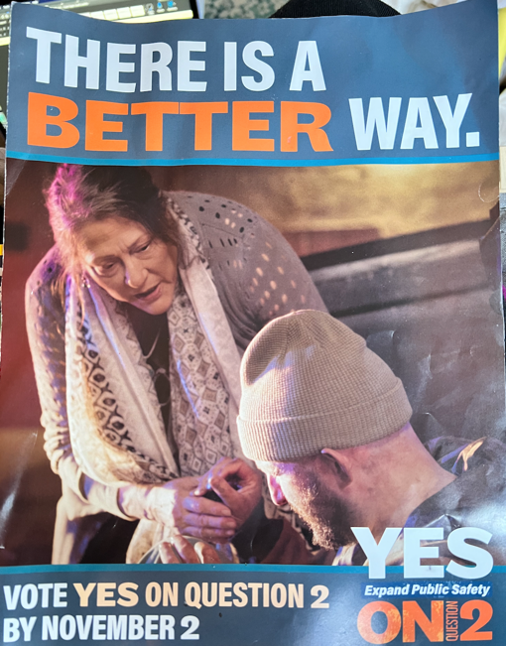
(Figure 1.2)
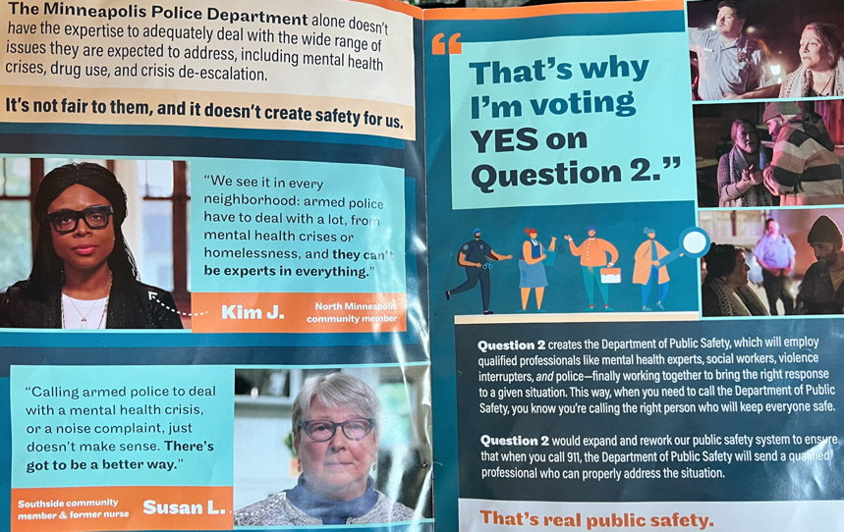
Yet while we know today that the Minneapolis constituency didn’t gain wins in the Public safety department, they did receive changes under affordable housing, which was a clear win for the constituency. This win also further proved positive in Lipsky’s final standard for political protest effectiveness, which asks whether it “provided power to powerless groups.” The progressive amendment, which pushed for Affordable housing, pictured below in Figure 1.3, passed, with 53% for and 46% against.
(Figure 1.3)
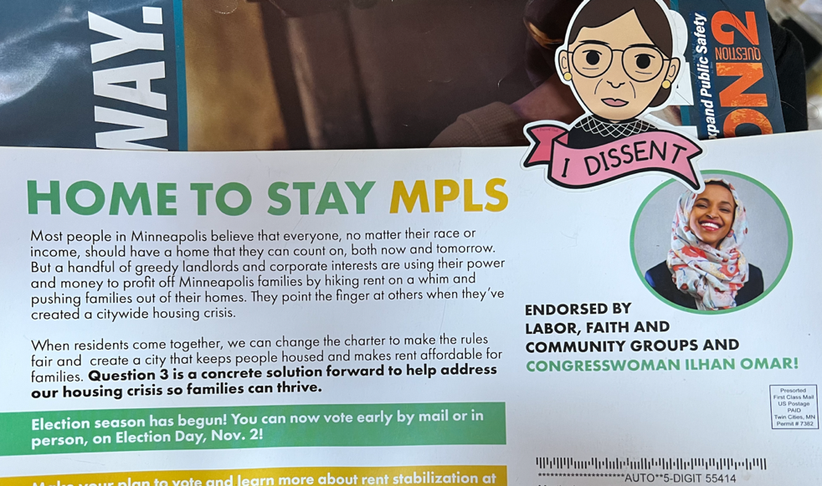
This helped exceedingly, those in low-income neighbors, and gave them more power economically where they may have felt powerless before. Clearly, Lipsky’s “4 standards of effectiveness,” each were successfully depicted in Minneapolis, which is a feat for any city under political protest. The voter using voice to produce action and change, was successfully illustrated in Minneapolis. While the 3rd and final strategy may argue that Minneapolis remains “neoliberal,” protest politics in Minneapolis argues differently.
When it comes to the Minneapolis city council, this was another area where the city sought change after not only the continuation of the “Black Lives Matter,” movement, but also in a push to make elections, candidates, and the city council not only descriptively more diverse, but also substantially more representative. Based by description, the Minneapolis City Council changed drastically after the 2018 midterms (Figure 2.1).

(Figure 2.1)
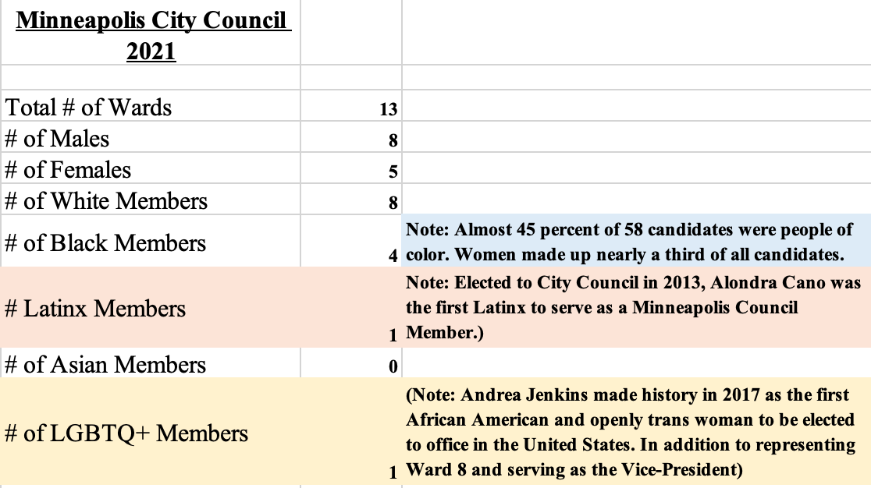
Other than providing a much more diverse city council than previous years, the council members also, such as Member Andrea Jenkins, started to make her mark by Declaring the Strategic & Racial Equity Action Plan (S+REAP), while also “declaring racism a public health emergency.” In this example, author Jane Mansbridge would argue that descriptive representation matters, because decisions Vice President Jenkins made on behalf of the black community were “deliberately relevant,” to perspectives of black constituents, but also to what policies were important to implement at that time. These moves on behalf of Jenkins, along with her voice on the council as its vice president, provided substantial policy promise to Minneapolis constituents. This also further proved that electing this type of representation, as a form of voicing protest by voting, allowed for this point in strategy 2 to be visibly successful.
The last important aspect under strategy 2 and the Minneapolis voters’ success in influencing a city’s progressiveness, is their collective action in coalition building.
Building coalitions is an important part of citizen action, in order for get progressive policy to be enacted, especially at the city level. In author Raphael Sonenshein’s model for coalition building, he argues there needs to be a unified “interest, ideology, and leadership,” and if all three are successful, the coalition will be. In Minneapolis, returning to the case of the “Yes for Minneapolis,” plan, throughout the process various coalitions boosted heavy media delivery (through flyers represented above) but also shared other TV and social advertisements. A prominent coalition in Minneapolis, “Black Visions,” built on the common interest and ideology of “Black Lives Matter,” unified to mobilize and act on this policy. During promotion for the “Yes4” plan, and hereafter, this coalition continues to implement strategies to get another amendment passed like that of “Question 4” (Figure 1.2), and under effective leadership (the 3rd part of Sonenshein’s model), continue to push for similar substantive policy. Coalitions like “Black Values” largely formed and unified after George Floyd, yet existed prior, and will continue to push for progress moving forward.
After possibly the biggest social movement of our lifetime, a more diverse city council, and action on behalf of interest groups, Minneapolis made strides toward change. Therefore, it can be contended that strategy 2, especially protest politics, is one of the largest contributors (if not the most impactful), in pushing Minneapolis towards “the progressive city.”

Strategy # 3:

Minneapolis political structures: measuring progress

The last strategy to argue against Minneapolis’ collective neoliberalism, can be argued through the positive or negative measurements of the progressive structures a city already has in place. For Minneapolis, we collected data in 4 core areas (including sub-areas), to measure each structure based in Social Justice, Environment/health impacts, Neighborhood Preservation, and Populism. In the data below, each area and sub-area is measured:
Social Justice
Immigration (Figure 3.1): Sanctuary Cities Refugee policies or resettlement programs.
Municipal ID system (no information on immigration status required)
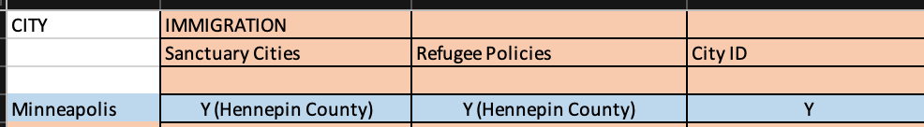

Affordable Housing (Figure 3.2) Inclusionary zoning, Housing Trust Funds, Rent control.
(NOTE: Since Data was collected, this has changed)
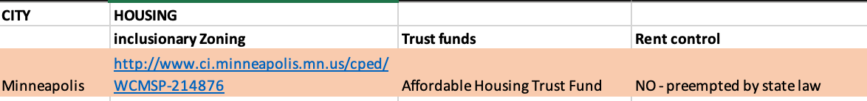
Affordable Housing 2 (Figure 3.3) Community Land Trust, Office-Housing Linkage Program
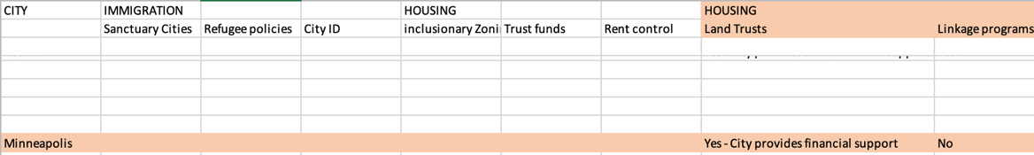

Education: (Figure 3.4) Charter Schools, Universal Pre-K
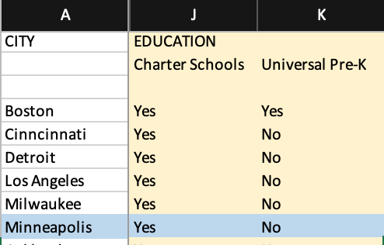
Jobs/wages: (Figure 3.5) Living Wage or Fight for 15, Mandatory paid sick leave.
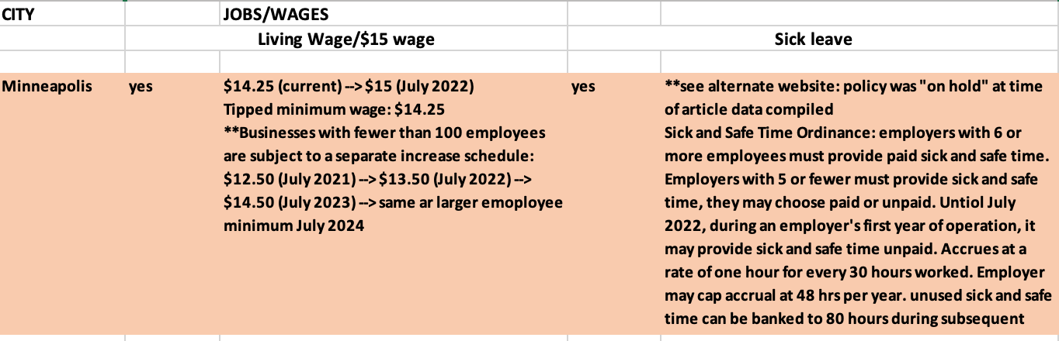
Business Climate measures: (Figure 3.6) pro-growth policies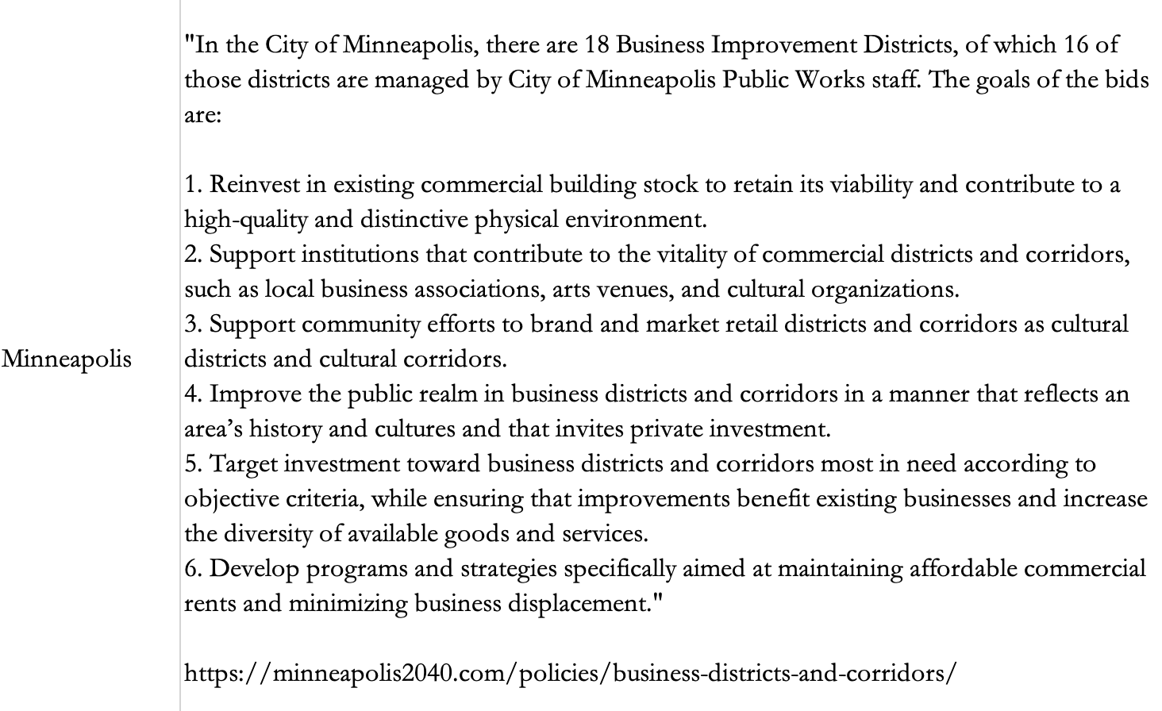

Environment Protection and Health
Composting (Figure 4.1)

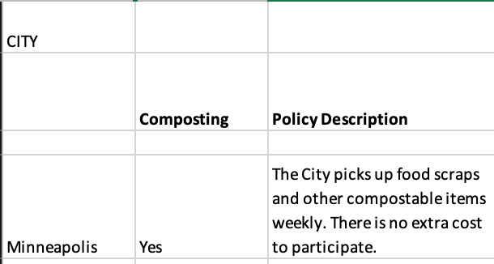

Free Mass Transit and Smoking Bans: (Figure 4.2)
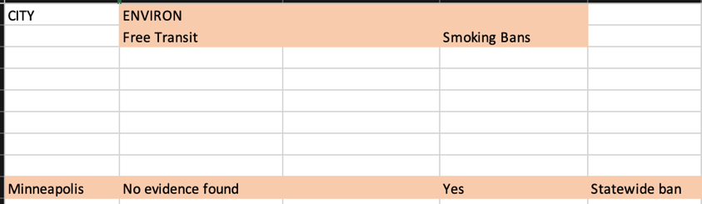
C4 Climate Initiative membership, EV purchasing, Bike Friendly (Figure 4.3)

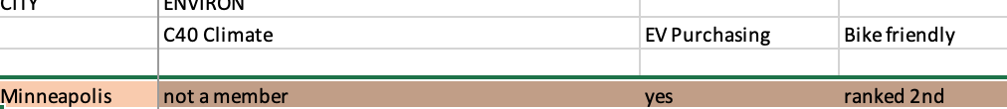
Neighborhood Protection
Historic Preservation Programs, Heritage City, Preservation Tax Credit (Figure 5.1)
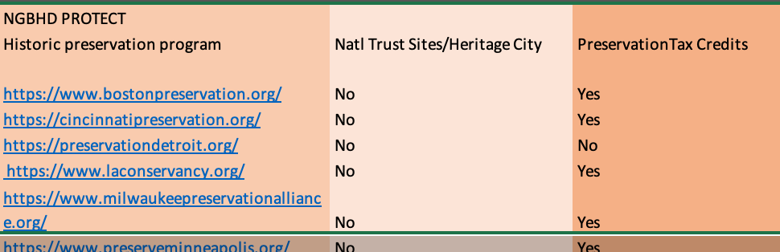
Populism:
Direct democracy: (Figure 6.1) Referendums & Participatory budgeting
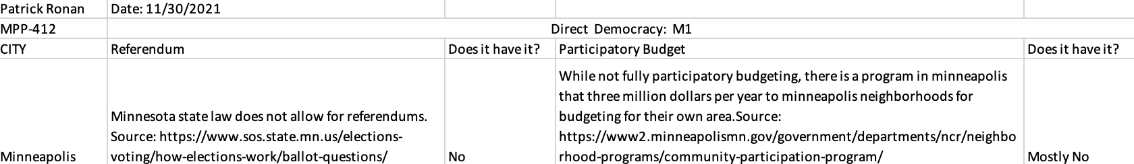
Overall, in the first core area, Minneapolis is seemingly on its way toward the ideal progressive city, advancing in all areas of Social Justice (depicted in Figures 3.1-3.6) When, highlighting education, Minneapolis ranks 7th in best public schools across the city and state. Similarly, affordable housing got a win in November in the “Yes 4 Minnesota” plan, with Question 3 passing providing Minnesotans better rent options and a new rent control policy. Finally, uniquely within social justice parameters, but not measured in our class data, Minnesota and comparably Minneapolis, are the best state and cities overall for Women to live, according to the Institute for Women Policy Research. In core area 2, they are environmentally sound, highlighting positive compost rituals and ranking 2nd “most bike friendly city.” In Core area 3 they have extensive preservation programs, including being home to many native America preservation lands, as Minneapolis is the original land for the Dakota tribe. Core area 4 argues for populism yet falls short with no referendums or participatory government.
Concluding, through the 3rd and final strategy to succeed, the 4 structure areas that argue a city progressive reach medium achievability, being progressive only in some areas while lacking in others. It can be argued this strategy, through measurement of progressive structures while not unsuccessful, remains far from successful.

Conclusion

In conclusion, while the city of Minneapolis is progressing in particularly areas, the question remains whether it is truly progressive. While aspects of Minneapolis’ urban politics debate the various criticisms of neoliberalism, it isn’t absolutely absolved of them.
Moreover, the 3 strategies that argue against Minneapolis being neoliberal are only partially successful. The first strategy, questioning whether redistributive services keep Minneapolis economically balanced, especially under constraints, is ultimately proved unsuccessful. Continuing, though the 2nd strategy of voters’ actions has shown success, especially recently through political protest, the 3rd and final strategy argues Minneapolis is only about a quarter of the way there in terms of successful measurement of values of progress. The City of Minneapolis, though seeing a revolutionary moment of social change, isn’t progressive, but it’s making progress.

Appendix:

(1)
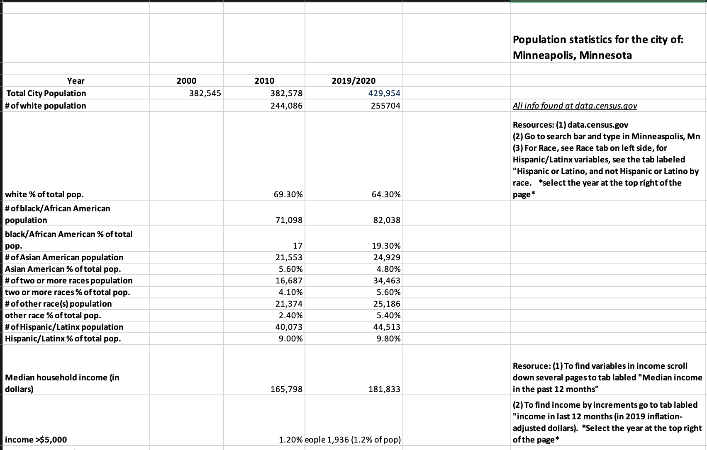

(2)
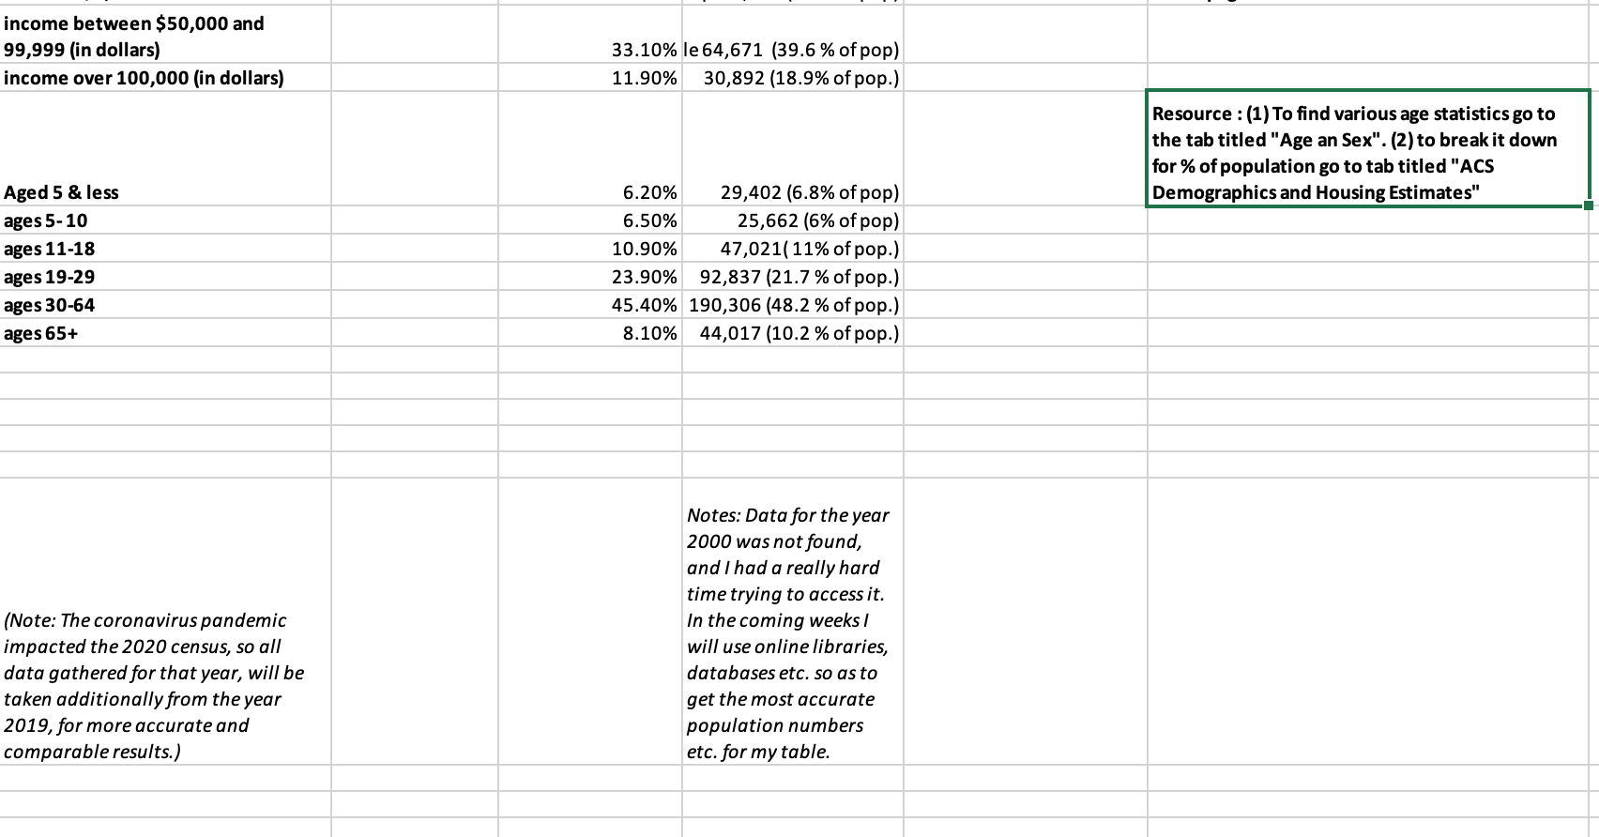

References:
About City Council. City of Minneapolis. (2021). Retrieved December 13, 2021, from https://www.minneapolismn.gov/government/city-council/.
Albert Hirschman. Exit, Voice, and Loyalty. Harvard University Press. Chapters 2-4, 7.
Best states for education 2021. (2021). Retrieved December 21, 2021, from https://worldpopulationreview.com/state-rankings/best-states-for-education
Black Visions Organization. How Much Money Has Been Redistributed So Far? __. (2021, June 17). Retrieved December 21, 2021, from https://www.blackvisionsmn.org/redistribution
City of Minneapolis. (2021). Ward 8 priorities and projects. Ward 8 Priorities & Projects - City of MPLS. Retrieved December 21, 2021, from https://www.minneapolismn.gov/government/city-council/ward-8/ward-8-priorities-and-projects/
Erdahl, K. (2021, December 17). Future monthly checks uncertain as Democrats struggle to cut a deal on Child Tax Credit. kare11.com. Retrieved December 21, 2021, from https://www.kare11.com/article/news/local/breaking-the-news/future-monthly-checks-uncertain-as-democrats-struggle-to-cut-a-deal-on-child-tax-credit/89-64446852-21c6-46e9-b3a2-05ee1a89147b
Goetz, E. G., Calhoun, M., Damiano, A., & Lewis, B. (2019, January 5). The diversity of gentrification: Multiple forms of gentrification in Minneapolis and St. Paul. Gentrification in Minneapolis & St. Paul | A project of the Center for Urban & Regional Affairs. Retrieved December 13, 2021, from http://gentrification.umn.edu/.
Hirschman, A. O. (2021, September 10). Exit, voice, and Loyalty. Wikipedia. Retrieved December 13, 2021, from https://en.wikipedia.org/wiki/Exit,_Voice,_and_Loyalty.
Huber, B. R. (2020, November 30). Covid-19 shutdowns disproportionately affected low-income black households. Princeton University: Princeton School of Public and International Affair. Retrieved December 21, 2021, from https://www.princeton.edu/news/2020/11/30/covid-19-shutdowns-disproportionately-affected-low-income-black-households
Is Minneapolis the best Minnesota City for your business? Minneapolis Population. (2021). Retrieved December 21, 2021, from https://www.minnesota-demographics.com/minneapolis-demographics#:~:text=Race%20%26%20Ethnicity%202020,%25)%20and%20Hispanic%20(10.3%25).
Journal, S., & Ansari, H. (2021, November 3). The MPLS. City Council will be majority people of color. MPR News. Retrieved December 21, 2021, from https://www.mprnews.org/story/2021/10/15/for-the-first-time-the-majority-of-minneapolis-city-council-members-will-be-people-of-color
Lipsky, M. (1970). Protest in city politics rent strikes, housing, and the power of the poor. Rand McNally.
Mansbridge, J. (1999). Should blacks represent blacks and women represent women, A Contingent Yes. Retrieved December 21, 2021, from https://wappp.hks.harvard.edu/files/wappp/files/should_blacks_represent_blacks_and_women_represent_women_a_contingent_yes1.pdf
Minneapolis, Minnesota, question 2, Replace Police Department with Department of Public Safety Initiative (November 2021). Ballotpedia. (2021, November). Retrieved December 21, 2021, from https://ballotpedia.org/Minneapolis,_Minnesota,_Question_2,_Replace_Police_Department_with_Department_of_Public_Safety_Initiative_(November_2021)
Minneapolis, Minnesota, question 3, allow for Rent Control Amendment (November 2021). Ballotpedia. (2021, November). Retrieved December 21, 2021, from https://ballotpedia.org/Minneapolis,_Minnesota,_Question_3,_Allow_for_Rent_Control_Amendment_(November_2021)
Minneapolis, MN. Data USA. (n.d.). Retrieved December 21, 2021, from https://datausa.io/profile/geo/minneapolis-mn
Mollenkopf, J. H. (1988). Chapter 2, The New Deal and After. The Contested City (pp. 47–96). essay, Princeton University Press.
Nelson, E. (2020, August 13). Civil unrest damage in St. Paul totals $82 million. Star Tribune. Retrieved December 21, 2021, from https://www.startribune.com/civil-unrest-damage-in-st-paul-totals-82-million/572092302/?refresh=true
Paul Peterson. 1980. City Limits. University of Chicago Press. pp. 17-32, 41-50, 77-82.
ProQuest Platform Release News and updates. (n.d.). Retrieved December 17, 2021, from https://support.proquest.com/s/article/ProQuest-release-news-updates?language=en_US
Protesters and looters descend on downtown Minneapolis. Star Tribune: Radio & Podcasts - News, Sports, Music, Events. (2020, August 27). Retrieved December 21, 2021, from https://www.audacy.com/wccoradio/articles/news/protesters-and-looters-descend-on-downtown-minneapolis

Raphael Sonenshein. Politics in Black and White. Princeton University Press. Chapters 1. (3-21) (theory of which groups form coalitions; determinants of coalition partnership).
Timothy Weaver. By Design or By Default? Varieties of Neoliberalism.” 2018. Urban Affairs Review. 234-266.
Sepic, M. (2021, May 25). A year after George Floyd's death, plans for Minneapolis Police Reform have softened. NPR. Retrieved December 21, 2021, from https://www.npr.org/2021/05/25/1000298293/a-year-after-george-floyds-death-plans-for-minneapolis-police-reform-have-soften
Taylor, D. B. (2020, May 30). George Floyd protests: A Timeline. The New York Times. Retrieved December 17, 2021, from https://www.nytimes.com/article/george-floyd-protests-timeline.html
Wang, H. L. (2020, December 5). Millions of census records may be flawed, jeopardizing Trump's bid to alter count. NPR. Retrieved December 21, 2021, from https://www.npr.org/2020/12/05/943416487/millions-of-census-records-may-be-flawed-jeopardizing-trumps-bid-to-alter-count

From “City Limits,” Paul Peterson
From “Exit, Voice, and Loyalty” A. Hirschman
Note: When looking into the most up to date demographic information for the city of Minneapolis, it is important to note that coronavirus pandemic, beginning to impact populations in March of 2020, therefore impacted the overall 2020 census. Data I gathered for that year, will be taken additionally from the year 2019, for more accurate and comparable results.)
See Appendix 1
From “Exit, Voice, and Loyalty” A. Hirschman
Note: it was at a total of 382,578 in 2010 and increased to 439,954 by the year 2020 (from data.census.gov)
See Appendix 1
Note: According to the University of Minnesota, “neighborhoods saw increases in the population with bachelor’s degrees at rates far exceeding the citywide trends, while racial change was inconsistent. This was accompanied by increasing inequality. Incomes for the top 10% of households in gentrifying neighborhoods increased by almost 15% compared to a decline of 5% for affluent households in vulnerable areas.”
From “Exit, Voice, and Loyalty,” (p. 50-54) A. Hirschman
See: Appendix 2
Note: Asian Americans are statistically the lowest voting bloc in America, because of this there is sometimes a correlation with how they feel about certain social justice groups. (From “https://www.pewresearch.org/”)
Note: starting in Early 2020, the Coronavirus pandemic took a large toll on the US population, and Minnesota was among several states hit the hardest, with more than 10,000 deaths. (From “cdc.gov)
From: “https://www.princeton.edu/news/2020/11/30/covid-19-shutdowns-disproportionately-affected-low-income-black-households”
From “https://www.startribune.com/civil-unrest-damage-in-st-paul-totals-82-million/572092302/”
From “The Contested City,” (p.53-62) J. Mollenkopf
From “https://www.kare11.com/article/news/local/breaking-the-news/future-monthly-checks-uncertain-as-democrats-struggle-to-cut-a-deal-on-child-tax-credit/89-64446852-21c6-46e9-b3a2-05ee1a89147b”
From “City Limits,” P. Peterson
From “Protest in City Politics” M. Lipsky
From “https://www.audacy.com/wccoradio/articles/news/protesters-and-looters-descend-on-downtown-minneapolis”
From “https://www.npr.org/2021/05/25/1000298293/a-year-after-george-floyds-death-plans-for-minneapolis-police-reform-have-soften”
Note: (the vote lost by only 7% points, 44% for and 53% against, the vote needed 51% to pass.) (From “https://ballotpedia.org/Minneapolis,_Minnesota,_Question_2,_Replace_Police_Department_with_Department_of_Public_Safety_Initiative_(November_2021”
From “https://ballotpedia.org/Minneapolis,_Minnesota,_Question_3,_Allow_for_Rent_Control_Amendment_(November_2021)”
From “https://www.minneapolismn.gov/government/city-council/ward-8/ward-8-priorities-and-projects/”
From “Should Blacks Represent Blacks and Women Represent Women? A Contingent "Yes"” (p. 629-640) J. Mansbridge
From “https://www.blackvisionsmn.org/yes4mn”

